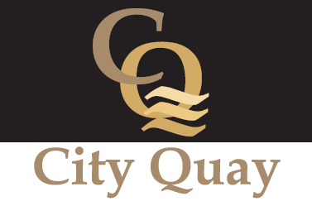
CITY QUAY MANAGEMENT (2001) COMPANY LTD
ANNUAL GENERAL MEETING 2016

Date and time: 11th July 2016 7.00 pm
Venue: Casemate No. 5, City Quay
AGENDA
- WELCOME AND APOLOGIES

- MINUTES OF LAST AGM

- GOVERNANCE

- CHAIR’S REPORT

- FINANCIAL REPORT

- ISSUES RAISED IN ADVANCE BY A RESIDENT

Waterford Group Management – unauthorised representation
Sub-letting – increased incidence, especially via Airbnb
Pet Policy – permissions, number of pets per apartment

- DATE AND TIME OF NEXT AGM: 10th July 2017. 7.00 pm, Casemate No.5

