YOU ARE CORDIALLY INVITED TO THE
AGM AND SOCIAL
of CITY QUAY MANAGEMENT COMPANY LTD
on MONDAY 11th JULY 2016 at 7.00pm
at CITY QUAY in CASEMATE No 5

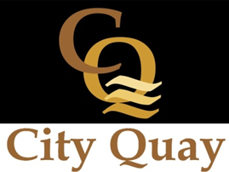

YOU ARE CORDIALLY INVITED TO THE
AGM AND SOCIAL
of CITY QUAY MANAGEMENT COMPANY LTD
on MONDAY 11th JULY 2016 at 7.00pm
at CITY QUAY in CASEMATE No 5

