All Seems Lost on Liverpool Maritime Mercantile City WHS

Gerry Proctor, Engage Liverpool

The expected World Heritage Committee meeting in 2020 suffered the same delays as most other programmed events and meetings since the Covid-pandemic erupted in the world. This meant that in Liverpool we continued to hope that our city will not be deleted from the list of UNESCO World Heritage Sites. To a civil society organisation such as Engage it is obvious that the global pandemic has dramatically affected one of the most important areas of our economy – tourism and the visitor economy. It has virtually ceased, and it looks very much like nothing will be restored for many months and possibly even years. And add to that the unknown impact of Brexit upon tourists from Europe and the city is facing a serious and potentially devastating crisis.

Losing such a prestigious status as a UNESCO WHS at this time would be a disaster – a real loss for the city but also a loss for humanity were that to happen. Our status sets us apart from almost every other city in the UK and places us alongside some of the most significant and most visited sites in the whole world. And the world gains an insight into a unique moment in global history at the height of the British Empire, in the design and build of an exceptional dock system that was a world-first which led to extraordinary prosperity for the citizens of Liverpool. The problem now is that our Outstanding Universal Value is under threat from development proposals, specifically the Everton FC stadium plans within the Bramley Moore Dock in Liverpool’s waterfront World Heritage Site as well as our lack of a tall buildings policy.

At the time of writing this piece for the World Heritage Watch Report 2021 the planning application for the stadium had yet to be presented to the Liverpool City Council Planning Committee and so to some extent we were all awaiting the decision of the Planning Department on whether they would recommend the application for approval. However, no one expected anything other than a positive recommendation to be presented to the elected representatives, and so it proved. And no one expected councillors to do anything other than approve it which they did unanimously. The nature of politics in the city has for some time been determined by the impact on the city council of the elected Mayor Joe Anderson, whose influence was widely felt across the city on many levels. However, in December 2020 he was arrested by the police for questioning in connection with offences concerning bribery and witness intimidation as part of an ongoing investigation into building and development contracts.

His arrest followed a year of extraordinary turmoil within the City Council particularly in the Regeneration Department which includes Planning. In December 2019 the Mayor’s appointed Director of Regeneration Nick Kavanagh was arrested by police and questioned over conspiracy to defraud and misconduct in a public office along with a developer from the city. He was re-arrested in September on suspicion of conspiracy to commit bribery along with a number of other individuals. It was hard to know what if any impact this would have on the World Heritage Site and specifically on the Bramley Moore Dock proposals. By the end of the year the UK Government had decided to send in inspectors to review the city and its governance arrangements and they issued a damning verdict and a devastating report.

During this year with the Covid health crisis and significant local political turmoil the City Council found time to publish the long-awaited North Shore Vision, that had been taken to Paris for a preview with UNESCO officials at the start of 2020, and whose virtual launch in September was attended on-line by Isabelle Anatole-Gabriel (Chief of the North America and Europe Unit at the World Heritage Centre in Paris) and other heritage officials from ICOMOS and Historic England. As we described in our report last year there is much to be admired in this Vision and it is a welcome addition to the city’s attempt to belatedly recognise the value of its UNESCO designation. It received very positive reports in the local and national media.

The crux of the argument now with UNESCO is really about the original decision to start a process that has deliberately led us to a place where the city, Everton FC and the landowner Peel are in the strongest position having invested millions in the project and brought most of the city on board with their public consultation processes. It needs to be said that during these consultations it was never explained that building inside the largest dock structure in the WHS Stanley Dock group of docks was not possible within the mutually approved guidelines and agreement signed by the government and UNESCO. So, it is not about whether we like the design of the proposed stadium or not nor the concept of it being on the waterfront, but it is the very idea of it being compatible with the nature of the WHS and the decision everyone made to protect its OUV (Outstanding Universal Value).

And the answer was known to all those who started this process, which does include Mayor Anderson (who is a strong supporter of the team), the landowner as well as the football club. There are no innocents here and during the years when this process was allowed to run unchecked the prevailing narrative coming from the Town Hall was that progress and development trumped everything and that UNESCO must not be allowed to stand in the way of this project. It is only at the last minute that some began to realise that there was after all some value in the designation that we are threatened with losing. And the North Shore Vision is part of that new effort to try and bring UNESCO and other heritage bodies to allow this development because everything else we will do in the future will be compatible with our being a World Heritage Site.

It is also a sad reality to note that most people think that if the proposed stadium doesn’t go ahead the dock will remain abandoned and desolate for ever – which of course isn’t true. It will take some time for land values to rise and the setting itself improve (it has a rather unsightly northern border with a working dock) before anyone might bring forward proposals acceptable to the landowner but also economically feasible for any potential developer. Yet it will be developed in due course. However, the city is now in a position where it has already prepared people for the loss of our status and the Mayor’s supporters are in the press regularly making the case for the stadium and against the ‘heritage lobby’, so should that happen the blue half of the city (Everton FC’s colours are blue and Liverpool FC’s red) will jubilantly welcome the stadium and most people will agree that development is what is needed right now. Few sadly will mourn the loss. The UNESCO narrative that values our being part of a global humanity by making a unique contribution to it no longer plays well in a society driven by nationalist populism and short-term development needs.

Engage is not the first or the only civil society actor to point out that had the city and landowner wanted to invite Everton to build a new stadium on the waterfront they actually had land available that would not have caused any problem at all with our WHS status. But they chose to offer the football club the water-filled largest dock in the complex which itself would have no monetary value for the landowner should it remain an open-water dock space. And the city’s Mayor loved to point out the truth that historically Liverpool always infilled its redundant docks and built upon them (the famous Three Graces at the Pier Head being a case in point).

Having personally attended the World Heritage Committee meetings in Krakow (41st session 2017) and Bahrain (42nd session 2018) I have seen for myself the political nature of the Committee meetings and noticed how blocks will form to support certain countries no matter what they have done to damage the OUV of their World Heritage Sites. I suspect Liverpool will also be affected by this geo-political reality when our case is brought to a vote. I cannot help but think about what I also picked up at the sessions, that it seems that the west is often held to standards that other countries are not expected to meet. The decision on Liverpool might now be made at the postponed 44th session which should take place in June/July 2021 in Fuzhou, Fujian province, China.

Engage would understand a negative decision from the World Heritage Committee, but we had wanted to request the World Heritage Committee not to delete Liverpool from the World Heritage List at its 44th Session but rather postpone such a decision until after the decision-making process in the UK has been finalized. There seemed to be a strong possibility that if the Planning Department recommend approval to the Planning Committee of Liverpool City Council then the UK Government would be asked to call it in for a full report from an inspector before making any decision. However, the UK Secretary of State Robert Jenrick decided against ‘calling in’ the decision and approved the plans so that the stadium can now go-ahead unopposed.

Everton FC had submitted their final plans to the City’s planning department and the revised drawings show some changes, notably the removal of a car park from the eastern edge of the site facing the River Mersey (figure 1) and its replacement with a much better stepped piazza overlooking the river which will be both a fitting start and end of an extensive walkway along the full length of the river; this has meant that fans will now have a covered entrance to the turn-styles along the river entrance to the ground (figure 2); and the height of the roof has been reduced and the area around the ground has been decluttered with energy-efficient power sources being moved to the roof of the stadium (figure 3). And Mayor Anderson has announced that he will withdraw from the forthcoming postponed elections in May. Engage had hoped that both the Government of the UK and UNESCO ambassadors would consider those ordinary citizens of Liverpool who desperately wanted to hold onto our status and who have always valued the decision made to inscribe our city as a World Heritage Site in 2004. But once again politicians have their reasons for the decisions they take and so we are now expecting certain deletion from UNESCO’s World Heritage List, becoming only the second European city to lose its status following Dresden Elbe Valley in 2009.

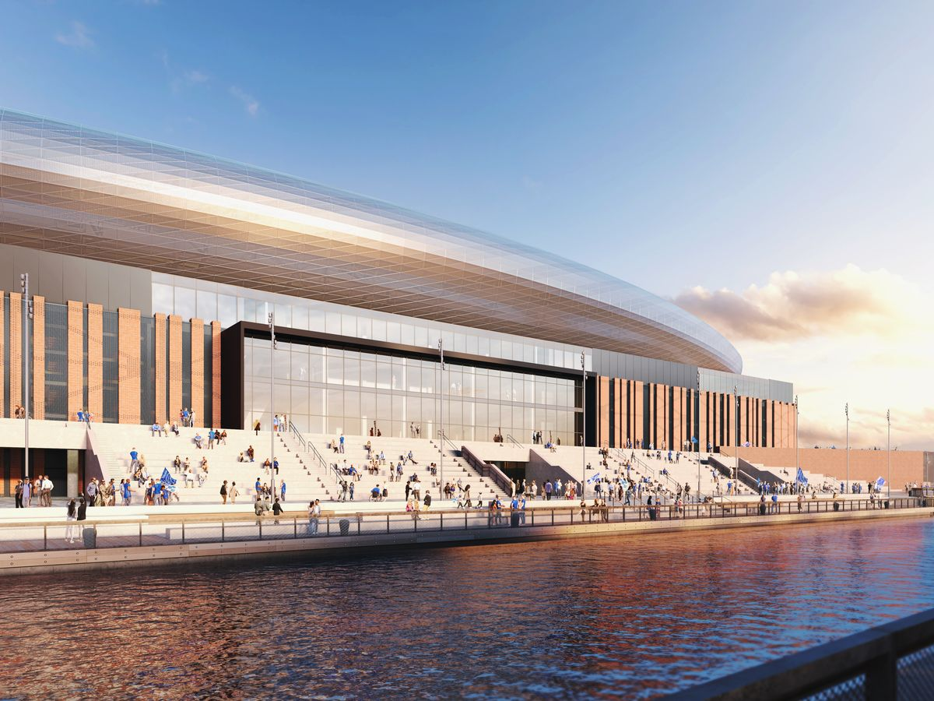

Figure 1: View of the central west stand. Source:
https://www.business-live.co.uk/economic-development/top-everton-official-speaks-out-18918733

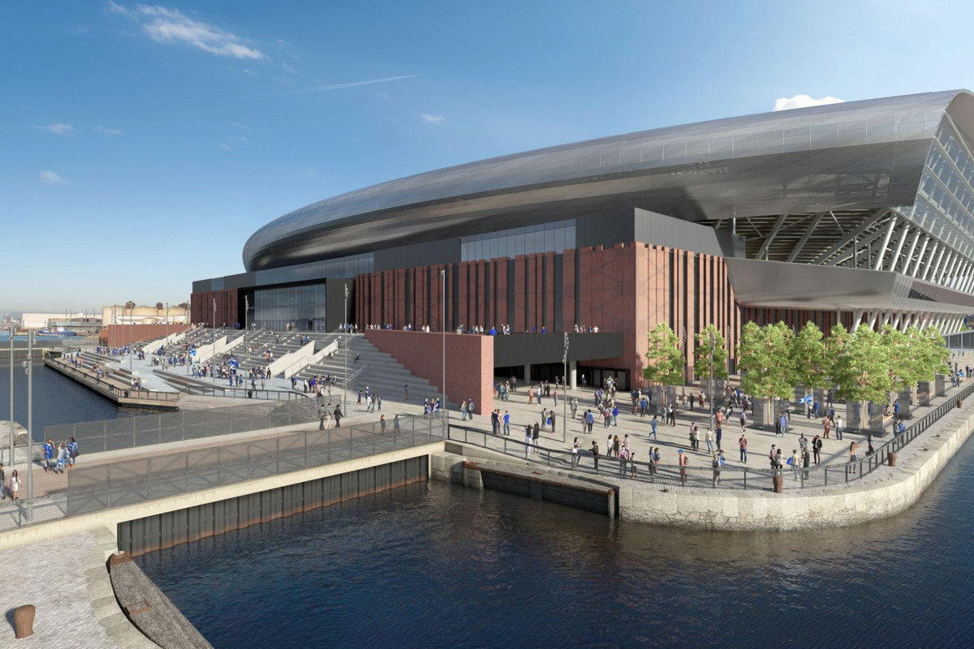

Fig. 2: A view from the southwest. Source:
https://royalbluemersey.sbnation.com/2020/8/26/21402765/everton-new-stadium-delay-latest-bramley-moore-designs-planning-application-unesco-world-heritage

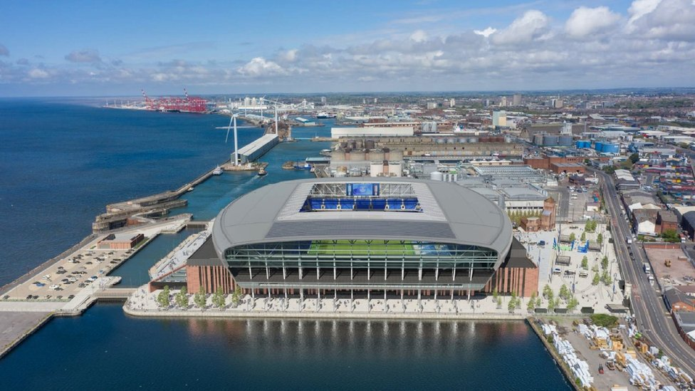

Fig. 3: A drone view of the planned Everton Stadium from the south. Source:
https://www.bbc.co.uk/news/uk-england-merseyside-53999295

https://whc.unesco.org/en/sessions/44COM
BBC News 04.12.20 https://www.bbc.co.uk/news/uk-england-merseyside-55192375
Liverpool Echo: 12.12.20 https://www.liverpoolecho.co.uk/news/liverpool-news/seven-days-rocked-liverpool-core-19432035
Liverpool Echo: 19.12.19 https://www.liverpoolecho.co.uk/news/liverpool-news/city-property-developer-council-regeneration-17445045; 10.01.20 https://www.liverpoolecho.co.uk/news/liverpool-news/arrested-council-chief-not-work-17540517
Place North West 03.09.20 https://www.placenorthwest.co.uk/news/kavanagh-among-five-arrested-by-merseyside-police/
https://assets.publishing.service.gov.uk/government/uploads/system/uploads/attachment_data/file/945913/Letter_to_Tony_Reeves_171220.pdf
Liverpool Echo: 17.12.20 https://www.liverpoolecho.co.uk/news/liverpool-news/government-investigation-launched-liverpool-council-19478159
https://www.engageliverpool.com/news/devastating-report-into-city-council/
Insider Media 10.09.20 https://www.insidermedia.com/news/north-west/heritage-led-plans-launched-for-liverpool-docklands-future; Local Gov 11.09.20 https://www.localgov.co.uk/Liverpool-launches-UKs-first-heritage-led-development-plan/51067; Environment Analyst 14.09.20 https://environment-analyst.com/uk/105938/liverpool-publish-plan-to-keep-un-world-heritage-status
LBN Daily 09.09.20 https://lbndaily.co.uk/heritage-lobby-scupper-evertons-stadium/
Liverpool Echo: 28.02.20 https://www.liverpoolecho.co.uk/news/liverpool-news/decision-day-edges-closer-evertons-17828508 (the Echo says that is unlikely but we are sure it will happen as the DSOCR states quite clearly that: “Where necessary the State Party will call in development proposals for determination at the national level rather than by LCC.”)
https://www.bbc.co.uk/news/uk-england-merseyside-56541316
Infrastructure Intelligence 15.09.20 http://www.infrastructure-intelligence.com/article/sep-2020/everton-fc-amend-new-stadium-design
Liverpool Echo 26.11.20 https://www.liverpoolecho.co.uk/sport/football/football-news/everton-new-stadium-designs-improved-19346486
Pitchcare.com 16.09.20 https://www.pitchcare.com/news-media/everton-submit-new-plans.html
New Civil Engineer 13.09.20 https://www.newcivilengineer.com/latest/everton-reduces-stadium-height-to-appease-historic-england-concerns-13-09-2020/
The Guardian 01.01.21 https://www.theguardian.com/uk-news/2021/jan/01/liverpool-mayor-joe-anderson-withdraws-from-elections?CMP=Share_iOSApp_Other
https://whc.unesco.org/en/news/522#:~:text=The%20World%20Heritage%20Committee%20decided,outstanding%20universal%20value%20as%20inscribed.%22

