

**Potential LFC Victory Parade**

**Business and Residents Information Pack**

*Huge crowds line the waterfront for LFC’s 6th European Champions League title in 2019 ©Liverpool City Council*

**LIVERPOOL City Council has invited Liverpool Football Club to take part in a victory Parade in preparation of the potential outcome of the season.**

The aim of this information pack is to give your business/premises notification as early as possible to enable you to prepare for the inevitable impact of this potential event.

Information includes; Map of full route, all Parade induced road closures and also a business advice letter.



10th May 2022

Dear Business Owner / Resident,

**Important Information:**

**Potential Liverpool Football Club Victory Parade**

**on Sunday 29th May 2022**

As you may be aware from recent press announcements, should Liverpool Football Club be successful in either the Premier League on Sunday 22nd May or in the Champions League Final on Saturday 28th May, Liverpool City Council will invite Liverpool Football Club to take part in a victory Parade on **Sunday 29th May at 4pm.**

The Liverpool FC team and any potential silverware will be Paraded on an open top bus through the city and is expected to last for several hours.

Due to the major logistical challenges involved in planning a Parade of this scale, the announcement and event details are being shared in advance, so that residents and businesses can make necessary preparations for any impacts the Parade may have.

**Parade Route**

The Parade route begins at Allerton Maze - onto Queen’s Drive – Millbank - West Derby Road - Erskine Street – Islington - Hunter Street - Leeds Street - The Strand – ending at the junction of the Strand and Blundell Street.

There is no further activity planned at the waterfront on completion of the route.

**Traffic Management Plan**

Significant road closures and traffic diversions will be in place well in advance of the event, and throughout its duration.

Due to the anticipated volume of spectators expected, vehicle movements of any kind within the city centre are discouraged throughout Sunday 29th May as access/egress cannot be guaranteed.

Access for emergency vehicles will be maintained via designated ‘Red Routes’.

**Information Pack**

Please see the Parade Route Map along with details of the roads and routes affected within this Information Pack which you are encouraged to read in detail.

Also within this pack you will find travel advice, latest FAQS, contact details for further questions and also road closure timings/locations.

**Potential LFC Parade – Sunday 29th May 2022**

**Key Business Messages**

**Travel Messages**

* Public transport will be much busier than usual so please discuss travel arrangements and any potential impacts of the Parade route with your employees who are scheduled to work that day.
* We encourage the use of public transport, taxis and active travel such as walking and cycling
* Visit [www.merseytravel.gov.uk](http://www.merseytravel.gov.uk) to check latest travel arrangements.
* We strongly advise against bringing vehicles into the city centre on Sunday 29th May as vehicle movements in and out of the city centre will be **significantly** impacted. If bringing a vehicle into the city centre is unavoidable, then give yourself plenty of time and expect **severe** delays in being able to access/egress the city centre by car.

**Hospitality venues – staff planning**

* Food and drink businesses within the city centre or along the route are expected to be extremely busy – please make sure you have sufficient stock levels well in advance of Sunday.
* During the previous Parade in 2019, restaurants and bars were very busy – please ensure you have appropriate staffing levels and stock to accommodate the expected increased demand.
* Look at shift patterns for venues along the route – if the route passes outside of your building it may be difficult for staff to get through crowds so you may wish to consider bringing staff in earlier than planned.
* If your building has good views of the Parade, people may be tempted to use your building as a vantage point. You are encouraged to consider additional security measures to mitigate for this.
* There will be no public toilets along the Parade route. If your venue has toilet facilities, there is likely to be significant demand/usage so may require additional resources and cleansing to manage this accordingly.
* Where possible, we advise staff who can work from home should do so.
* If you are hosting an event or function during the day, please advise the organiser to contact attendees to advise them to check how they will access the venue on the day and also allow plenty of time to arrive.

**Plan in advance for deliveries**

* Please arrange for all non-essential deliveries to take place prior to Sunday 29th May as access cannot be accommodated on Parade Day, particularly in the city centre.
* For all essential deliveries / cash collections etc please plan around the Parade timings and arrange for these to happen early morning or later at night as access cannot be accommodated due to anticipated spectator levels.

**A-Frames and Pavement Cafes**

* Due to the volume of spectators expected to attend this event, we ask all businesses along the route to refrain from putting out **any** infrastructure or obstruction on the highway at any time during the 29th May, particularly those that can be used as climbing aids to gain vantage views. This includes pavement signs, A-frames and other such signage.

**Hotel & Apartment Guests and visitors to venues**

* Please advise hotel guests about the Parade route and timings, particularly those who have trains, flights etc to catch. Guests will need to plan their pickup / drop off points accordingly and give themselves plenty of time.

**Potential LFC Parade –** **Sunday 29th May 2022**

**Road closure information**

**The Strand**

Please note The Strand will be closed northbound from the Upper Parliament Street / Great George Street junction to Leeds Street / Great Howard Street junction from 07.00 – 23.00 or until it is safe to re-open.

The southbound lane will be closed from approx. 13.00 – 23.00, again subject to crowd safety requirements.

**Access to and from Royal Albert Dock for business owners and residents.**

Access to Royal Albert Dock will be via Upper Parliament Street, St James Street or Jamaica Street, Blundell Street crossing Wapping into Queens Wharf, left at the roundabout to Half Tide Wharf, Kings Parade, Gower Street.

Vehicles exiting the Royal Albert Dock should follow the same route back.

Please note it will not be possible to turn left or right when crossing over the Strand nor will it be possible to exit via Gower Street.

**Access to Mariners Wharf and Sefton Street for business owners and residents.**

Due to the large crowds anticipated, we would suggest Sefton Street and Mariners’ Wharf is accessed from the South i.e. Jericho lane, Riverside Drive, Sefton Street and the reverse for egress. Access will be possible from the usual diversion from Parliament Street, Grafton Street, Stanhope Street, Sefton Street, Mariners Wharf but this will no doubt get extremely busy in the build up to the Parade with the Strand being closed so access/egress cannot be guaranteed.

**Access to Pier Head for business owners and residents**

Access to Princes Parade will be via Scotland Road (A59) to Boundary Street, Regent Road, Waterloo Road, Princes Parade, St Nicholas Place and Canada Boulevard. Exit will be the reverse.

**Access to and from M&S Bank Arena**

Access to the M&S Bank Arena will be via Upper Parliament Street, St James Street, or Jamaica Street, Blundell Street then crossing Wapping into Queens Wharf.

Vehicles exiting the campus should follow the same route out.

Please note it will not be possible to turn left or right onto the Strand.

**Access to Princes Parade for business owners and residents.**

Access to Princes Parade will be via Scotland Road (A59) to Boundary Street, Regent Road, Waterloo Road then Princes Parade. Exit will be the reverse.

**Parade Map**

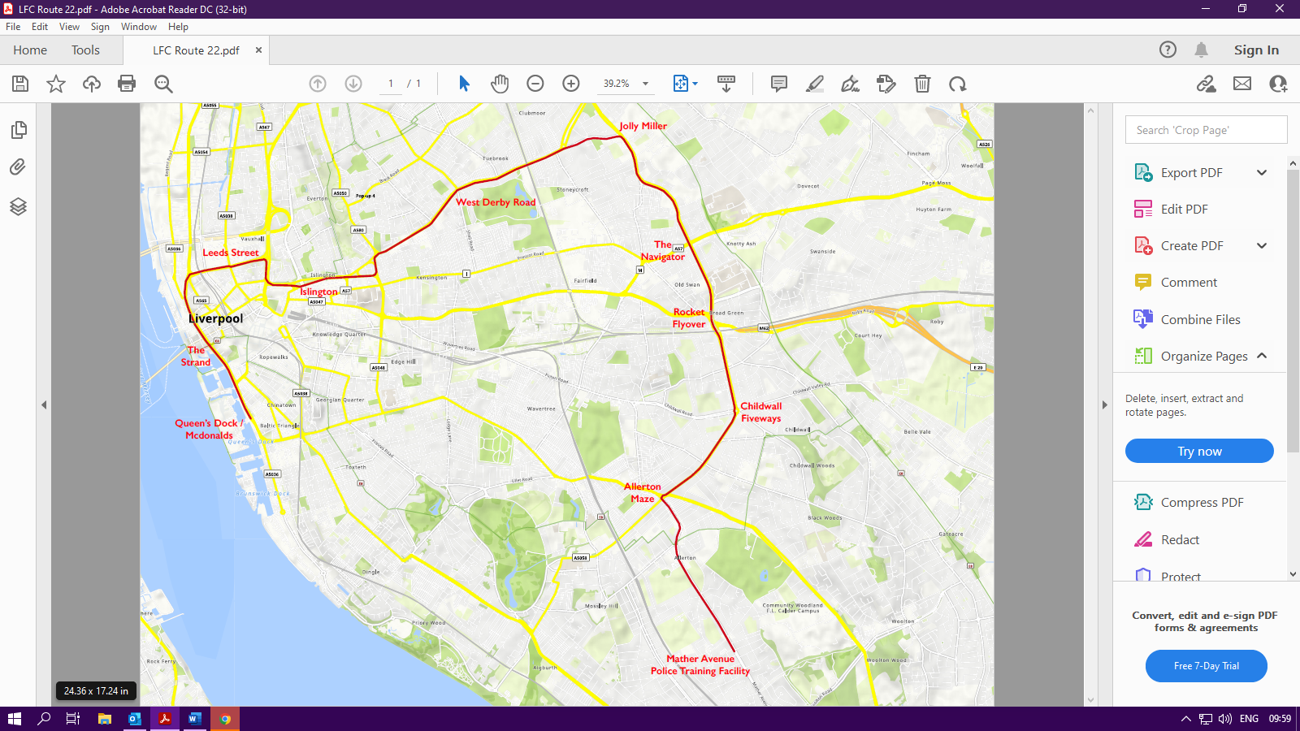

**Frequently Asked Questions**

|  |  |
| --- | --- |
| **When is the Parade taking place** | Sunday 29th May |
| **Parade Timings** | The Parade is planned to start at 16.00 and it is expected to last for a number of hours.  We cannot predict the end time of the event and request that the public / businesses take this into account. |
| **Who can attend?** | The Parade is free for everyone to attend.  Please be advised however, if you are bringing young children to the event, that prams can be difficult to navigate in the crowds.  Also, for those with restricted mobility or who require walking assistance, there will no designated seating along the Parade route. |
| **Where is the best view of the Parade?** | The Parade bus will be visible along a pre-planned route in Liverpool  There is a downloadable map of the route on the Culture Liverpool website.  There is no viewing area that is more advantageous than others – there will be animation along the entire route.  We advise that you watch the Parade at a location close to your home that you can walk to and from; there will be significant road closures and diversions in place for all vehicles in the city that day and public transport to and from the city centre is also going to be extremely busy.  We strongly advise you plan ahead and view the Parade from as close to your home as possible.  It will not be possible to follow the full length of the Parade route. |
| **Will there be accessible viewing?** | There will be viewing throughout the Parade route but due to the nature of the event, it is not possible to provide specific accessible viewing areas. |
| **Where can I get up to date information on the Parade?** | Social media will provide live updates on the day of the Parade.  Please follow:  Liverpool City Council on Facebook and @LpoolCouncil on Twitter  Culture Liverpool on Facebook and @CultureLpool on Twitter.  Liverpool Football Club social media will be live from the event Parade on @LFCHelp on Twitter.  There will be travel messages issued by Merseytravel on their channels  All messages regarding safety, travel and updates will be circulated on the Culture Liverpool event channel.  The Google map of the route is available to see on the Culture Liverpool website [www.cultureliverpool.co.uk](http://www.cultureliverpool.co.uk) which features the full route in an interactive map. |
| **How can I find out where the LFC bus is?** | Social media Twitter channels will have live updates:  LFC on @LFCHELP  Liverpool City Council on @LpoolCouncil  Culture Liverpool on @CultureLpool |
| **Can I bring flares to the event?** | The use of flares, pyrotechnics, or anything similar is illegal and strictly prohibited at the Parade event.  Any individual found carrying and bringing these items to the Parade may face prosecution. |
| **Will there be parking facilities?** | Due to crowd numbers and extensive road closures, we advise anyone wishing to view the Parade to do so as close to your home as possible and walk to and from this location.  There will be no parking facilities available.  We strongly advise against driving to the event and we strongly advise against bringing vehicles into the city centre due to the significant road closures are diversions in place. Vehicle access and egress by vehicle cannot be facilitated along the Parade route and long delays are likely until crowds have dispersed. |
| **Will there be any public toilets along the route?** | There will be no toilet facilities available along the route. |
| **Road Closures** | Please note the Strand will be closed northbound on 29th May from Leeds Street / Old Hall Street junction to Blundell Street junction from 07.00 or until it is safe to re-open.  The southbound lane will be closed from approx. 13.00, again subject to crowd safety requirements.  The closures for Allerton Maze, Queen’s Drive, Millbank, West Derby Road (outward bound), Erskine Street, Islington, Hunter Street and Leeds Street will not be implemented until the Parade approaches, unless the crowd volumes dictate otherwise.  West Derby Road city bound will also be closed from Sheil Road at 16.00 until the conclusion of the Parade in this area. |
| **I want to attend the Parade, how do I get there?** | In the interests of public safety, there will be a number of roads closures in place (as stated above) to allow the Parade to proceed.  We strongly advise that you pre-plan your journey and check [www.merseytravel.gov.uk](http://www.merseytravel.gov.uk) and direct with transport operators for detailed information on bus, rail, Mersey Ferries and Mersey Tunnels.   * Plan your travel in advance to ensure you can get where you are going to go and how you get home again. * If you live along or close to the route, stay local and walk or cycle. This may give you the best vantage point and means you can avoid a busy transport network. * The open top bus won’t be stopping so take advantage of the full length of the route. * Plan ahead and allow time for your journey. The transport network is expected to be very busy before and after the Parade, particularly as it falls within rush hour. You may have to queue. * If you don’t intend to stay and watch the Parade, consider travelling home from the city centre earlier than usual * If you are planning to visit the city centre but do not intend to watch the Parade, consider making a trip to the city centre on an alternative day. * Decide which part of the route you want to attend and arrive in plenty of time. * Use public transport wherever possible, but do keep in mind that bus services in and out of the city centre and those that cross the Parade route will be delayed and disrupted by road closures and diversions. * Be patient – it is impossible to predict how long it will take the team bus to travel along the route. This will also impact on when road closures will be lifted and when affected bus routes can get back to normal. |
| **Will the Parade go ahead if there is bad weather?** | Yes, the Parade will still go ahead as normal if it is raining. The British weather can be unpredictable, so **please** plan for the weather.  In consideration of others in the crowd, we ask that you please avoid using umbrellas as these can spoil the view of those behind you. If you are using an umbrella, you may be asked to take it down.  Please take the necessary precautions with sun cream, hats, sunglasses and appropriate attire for children, young people, adults and the elderly if the weather is warm. |
| **Can I bring my dog along?** | We would strongly advise against bringing any pets, other than assistance animals, to the Parade due to crowd volumes and loud noises which can be distressing to animals. |
| **Covid Information** | Please see advice below from Public health,   * Stay at home if you display Covid symptoms, as you should with any viral infection * Self-isolate for 10 days if you test positive (you may be able to reduce this to six days if you test negative in the meantime) * Wear a face covering in enclosed or busy spaces (e.g., a lift) * Wear a face covering when in close contact with anyone elderly or vulnerable * Ensure your Covid vaccinations are up to date |
| **Environmental Considerations** | If you bring refreshments and food items of any kind with you, please take all of your rubbish home with you – if you bring it before the event, take it back home after the event.  Please also use recyclable or environmentally friendly items – avoid single use plastics wherever possible. |
|  |  |

**Contact**

Should you have any specific questions or queries that are not addressed above, please contact Culture Liverpool events team via:

|  |  |
| --- | --- |
| **Event Duty Phone** | 0151 300 0351 they are open Mon – Sat 0930 – 1730 and 1030 – 1700 on Sunday |
| **E-mail** | [cultureliverpool@liverpool.gov.uk](mailto:cultureliverpool@liverpool.gov.uk) |
| **Postal address** | Liverpool City Council, 3rd floor Cunard Building, Water Street, Liverpool L3 1AH |